User guide – v.0.1

This guide describes how to use the pipeline presented in: ”Integrated Brain Atlas for Unbiased Mapping of Nervous System Effects Following Liraglutide Treatment”.

The guide has three main parts:
- Brian atlas
- Quantification of peptide distribution
- Quantification of brain activity

Author: Casper Jensen, Email: dtu.brainpatterns@gmail.com
17-MAY-2018,

Brain atlas 3
Brain distribution 4
Create Imaris file 4
Create unmix channel 6
Align the samples to the brain atlas 7
Compute average brain distribution 13
Comparing distributions 15
Quantify the brain distribution 17
Brain activation 20
Copy analysis files to study folder: 20
Run construct_mosaic.exe 20
Run select_params 21
Runs iDISCO_quant 23
Check atlas alignment 25
Compute group average heat map 28
Comparing brain activation signals 29
Subtract vehicle signal 31
Extract statistics 32

Brain atlas
The tools are based on material downloaded from the data portal of the Allen Brain Institute of Brain Science (AIBS). Some of the material has been reordered and imported into Imaris for visualization. To visualize the brain atlas in 3D:
Open the provided Imaris file named “allen_atlas.ims” in the folder ”C:\myXT\quant_templates”
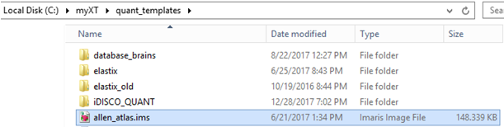

The file contains a modified version of the AIBS CCFv3 anatomical reference brain, the anatomical reference brain of the Allen Mouse Brain atlas, and a subset of annotation regions included in the atlas. An average unmixed auto-fluorescence channel is also included.

CCFv3 template | Nissl-based template | Avererage unmixed auto-fluor | Selected annotations
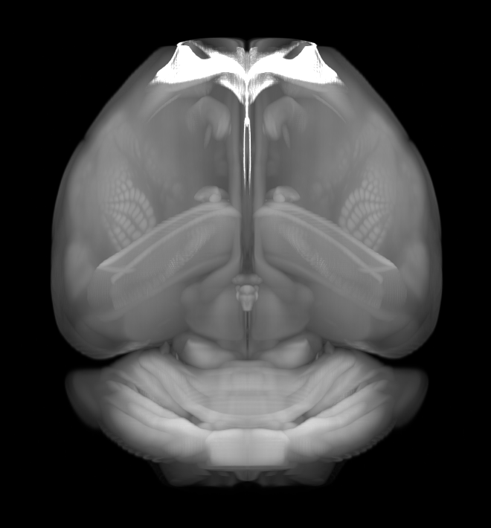 | 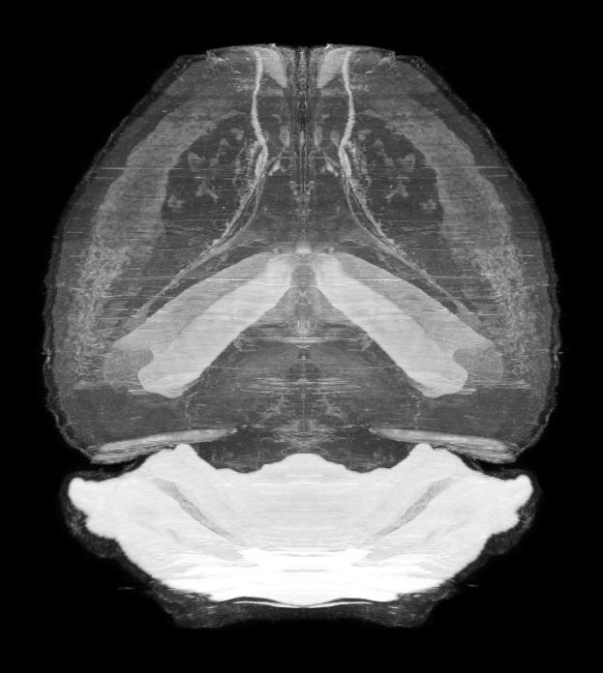 | 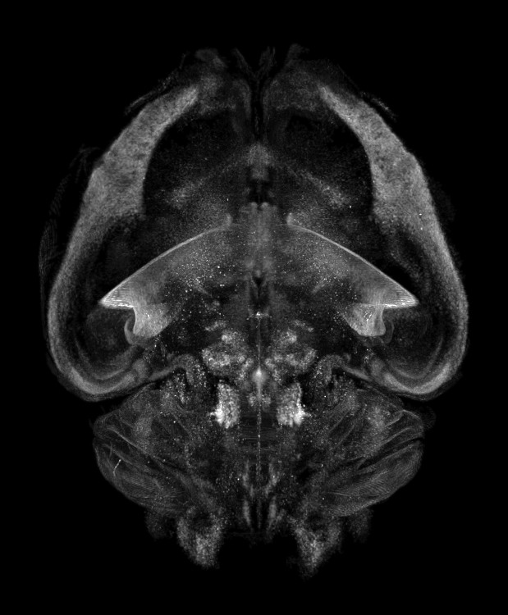 | 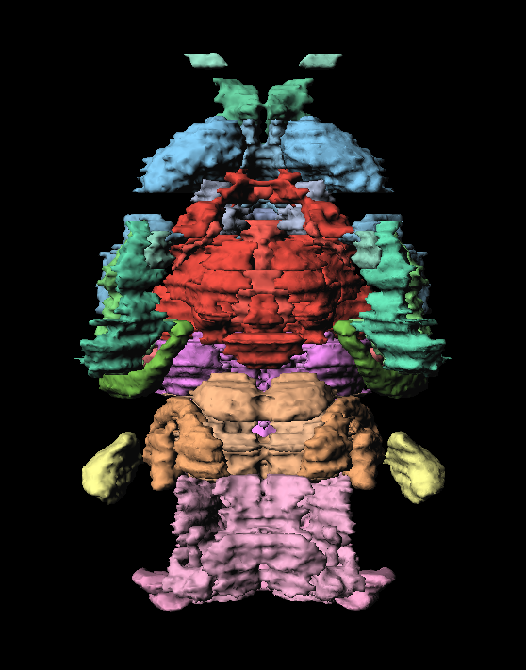

This atlas file can be copied to any study folder and be used to import peptide distributions, brain activity heat maps etc for visualization together with the atlas. More details are provided later in this guide.

Brain distribution
A brain distribution study contains a number of brains for one or more study groups. The steps required to quantify the distribution is as follows:
- Create an Imaris file for each brain
- Create an unmix channel
- Align the samples to the brain atlas
- Compute average brain distribution
- Quantify the brain distribution

Create Imaris file
From Imaris open the first image in the two channel tiff stack in 10 um resolution. In this example brains were scanned with x=y=5µm and z=10µm, thus resample opening with x=y=2, z=1 was used to achieve the isotropic 10 µm resolution.

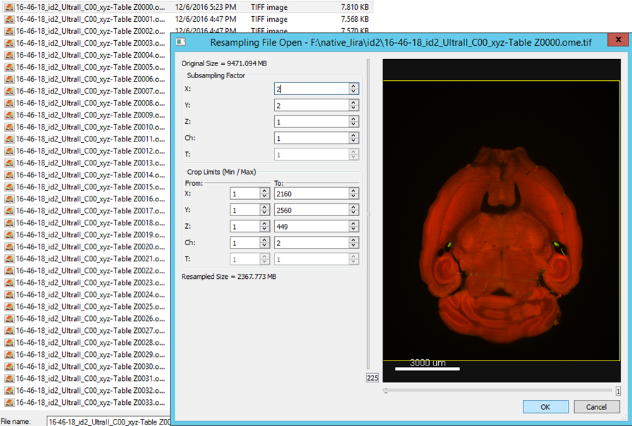

The data set should consist of an auto-fluorescence channel and a specific channel with the labelled peptide.
Auto-fluorescence channel | Specific channel
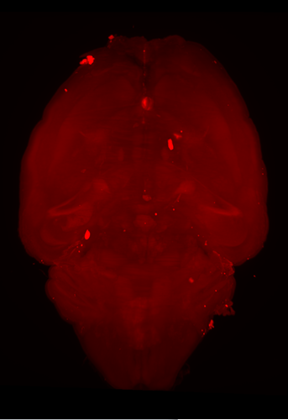 | 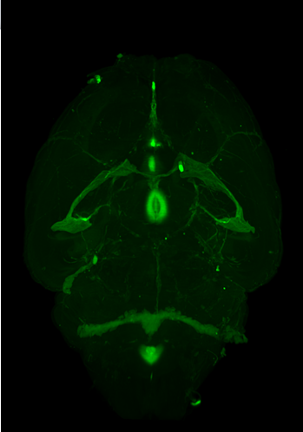

Use 3D crop to remove any additional background from the image volume.
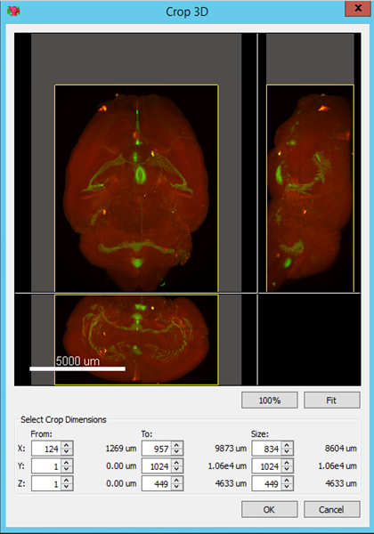

Rename the auto-fluorescence channel as: ”auto” and rename the specific channel as: ”spec”
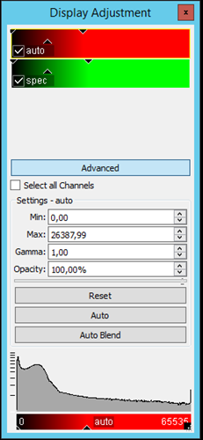

Create unmix channel
Run the “CSBJ unmix” plugin from the Image Processing tab to create a new channel with minimized auto-fluorescence contribution in the specific channel. A pop-up window will show the progress:
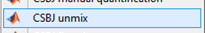

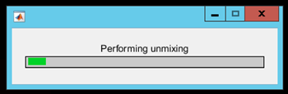

Once the algorithm has finished running an additional channel named “unmix” will be added to the data set:
Auto-fluorescence channel | Specific channel | Unmix channel
 |  | 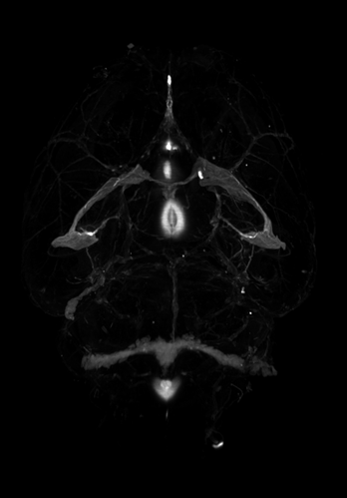

Save the Imaris file in the folder containing the tiff files as e.g. “id_x.ims”. Repeat the above steps for all samples in the study.

Align the samples to the brain atlas
Copy “C:\myXT\quant_templates\batch_info.xls” to the study folder. Next, create a new folder for each group in the study, e.g. “group1” and “group2”. Then copy “C:\myXT\quant_templates\brain_atlas.ims” to the study folder as well as to the individual group folders. Rename “brain_atlas.ims” to the group name, e.g. “group1.ims”.
Study folder:
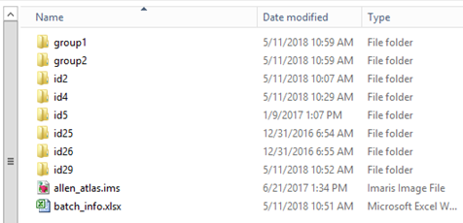
Individual group folder:

Then, open “batch_info.xls” and fill in the “analysis_info” tab. Choose the brain regions to use in the subsequent quantification by adding the brain region name to the list in column A. The full list of brain regions that can be included can be seen in: “C:\myXT\brain_atlas\snap_labels_large.txt”.
In the “analysis_info” tab the “threshold for volume measure” should as standard be set to zero. The threshold will discard all pixels in the unmix channel below the threshold value.
Resolution info and channel info should not be changed.
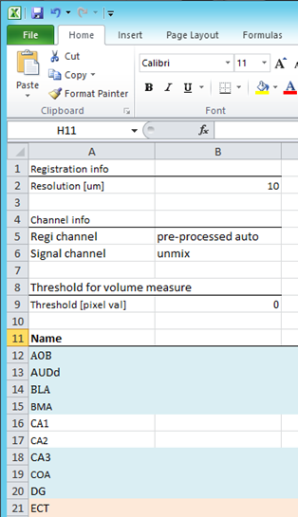

Next, fill in the info for each study group in the group tabs. Row 2 should contain the path to the group folder created and the filename for the renamed “brain_atlas.ims” file. An additional row should be filled in for each sample in the study group. Again the path to the folder containing the imaris file as well as the imaris file name should be filled in.
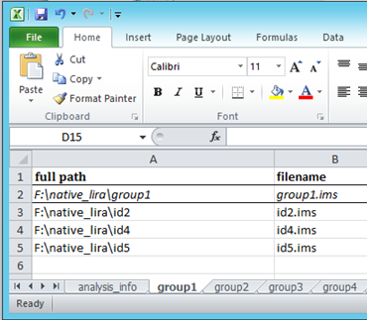

Repeat the above steps for all groups in the study.

To align the samples to the brain atlas goto “Image Processing” -> “CCFv3 analysis”

Select “atlas registration in the pop-up window
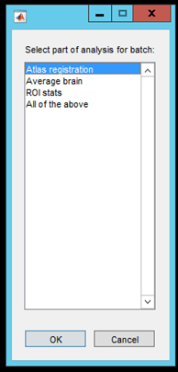
Navigate to the study folder and click “select folder” in the next pop-up window
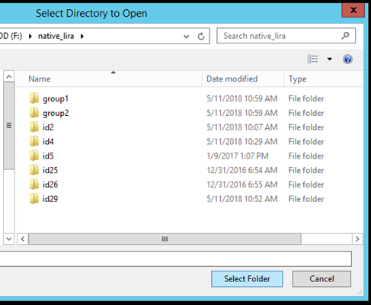

Select the groups to be aligned to the atlas in the final pop-up window and click “ok”
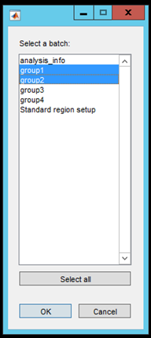

The imaris files will first be pre-processed one by one. The progress can be followed in the progress bars
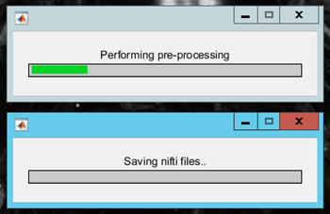

After pre-processing the actual atlas alignment is performed. The progress can be followed:
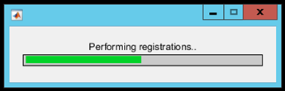

When the registration is complete some additional files will be generated in each sample folder:
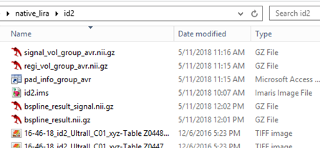

The file “regi_vol_group.nii.gz” contains the pre-processed version of the sample, while “signal_vol_group_avr.nii.gz” contains the corresponding unmix channel. The file “bspline_result.nii.gz” contains the aligned sample, and “bspline_result_signal.nii.gz” contains the aligned unmix channel. The alignment quality can be tested by opening “bspline_result.nii.gz” and “C:\myXT\brain_atlas\allen\lsfm_template_auto_nresult_man.nii.gz” with ITK-SNAP.
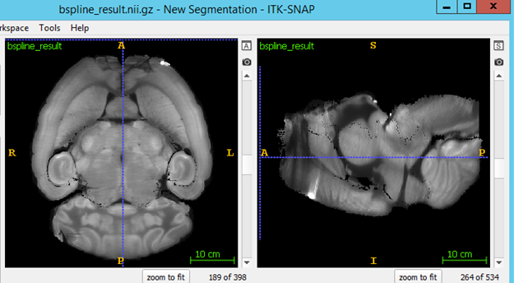

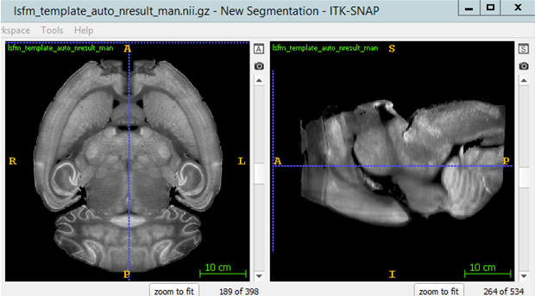

Compute average brain distribution
Goto “Image Processing” -> “CCFv3 analysis”
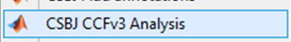

Select “average brain” in the pop-up window
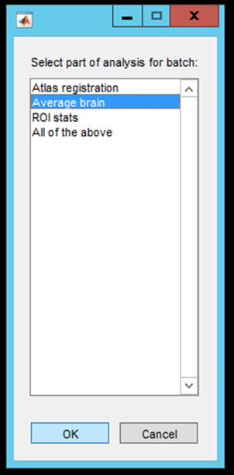

Navigate to the study folder and click “select folder” in the next pop-up window.
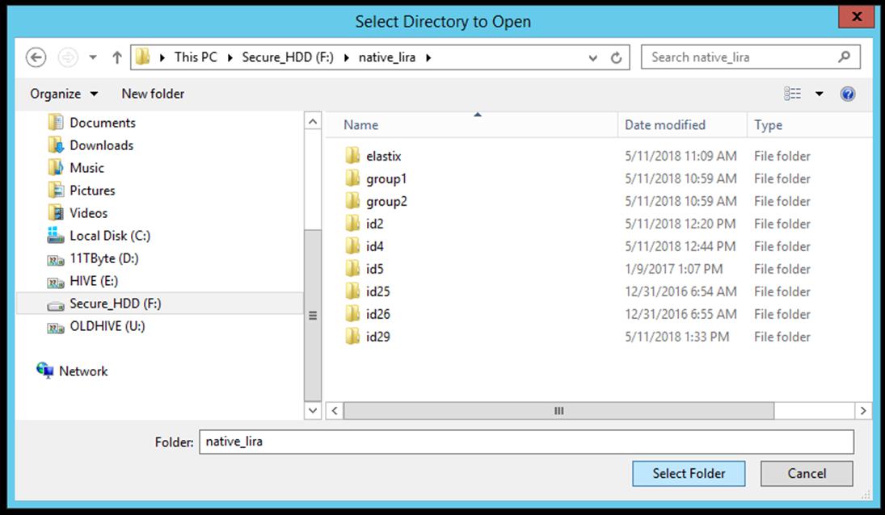

Select the group for which an average distribution should be computed
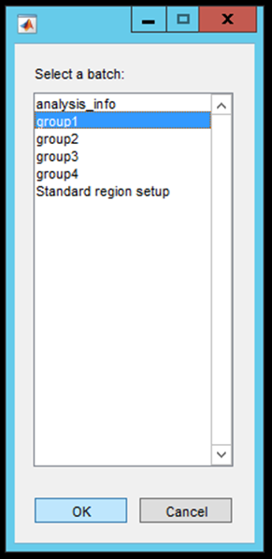

The average brain will automatically be imported to the imaris file placed in the study folder (here “group1.ims”). The average distribution may then be visualized with the CCFv3 template of the AIBS atlas.
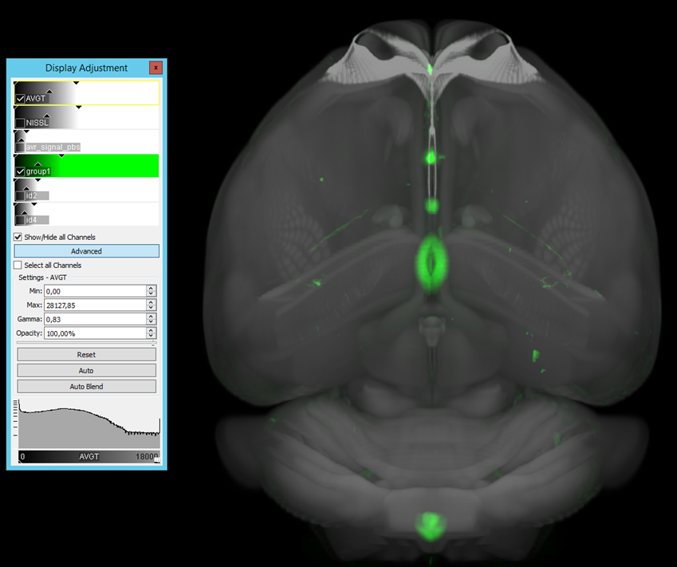

Repeat for all groups in the study.

Comparing distributions
It is also possible to visually compare different brain distribution signals in the same Imaris file. After the average brain has been computed a nifty file is saved with the result, e.g “group1.nii.gz”.
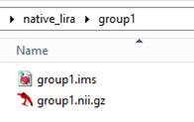

This nifti file with the average distribution signal from each group can be imported into the “allen_atlas.ims” placed in the main study folder and be directly visually compared. First, open the “allen_atlas.ims” file.
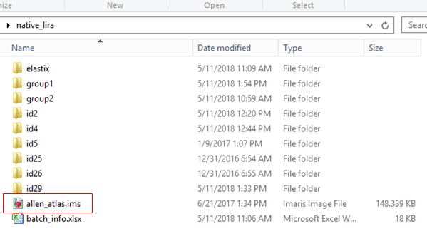

Goto: “Image processing” -> “CSBJ Open nifi”
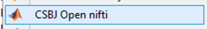

Select “Add channel to existing file” and click “ok”

Navigate to the “group1.nii.gz” file. Select it and click “Open”
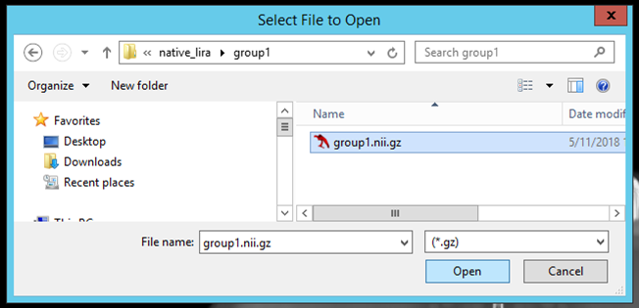

The average distribution signal will now be imported as a separate channel in the imaris file.
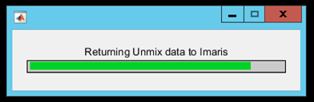
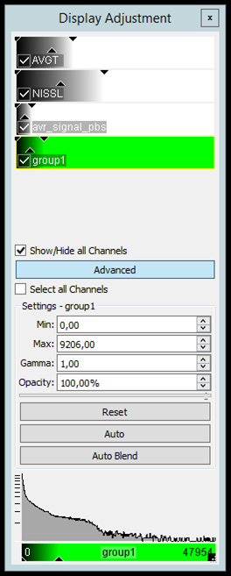

Repeat for all study groups.

Quantify the brain distribution
Goto “Image Processing” -> “CCFv3 analysis”

Select “ROI stats” in the pop-up window
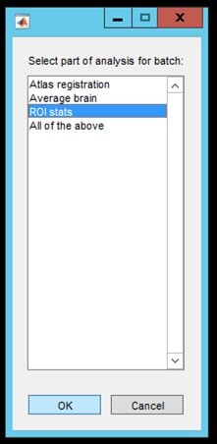
Navigate to the study folder containing “batch_info.xls” and click “select folder”
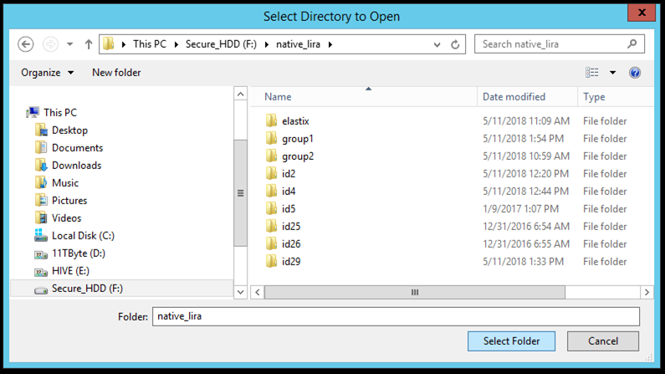

Select the group for which the quantification should be performed

The ROI stats will then be computed. The results will be saved as a .csv file in the study folder. For statistic comparisons use the value in “brain_region_name Tot_sig”. This value contains the voxel-wise summation of the unmixed intensity values for each brain region selected to be included in the analysis.

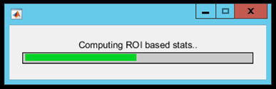

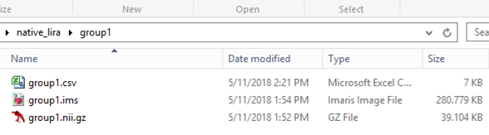

Brain activation
The data set must contain an auto-fluorescence channel and a specific channel. The tiff files from each channel must be located in separate folders named as follows:
Auto-fluorescence channel: Path_start\c000\path_end\
Specific channel: Path_start\c001\path_end\
The steps for analysis are as follows:
- Copy analysis files to study folder
- Run construct_mosaic.exe
- Run select_params
- Runs iDISCO_quant
- Run avg_brain
- Run ROI_stats

Copy analysis files to study folder:
Copy “C:\myXT\quant_templates\iDISCO_QUANT” to the study folder containing the brain samples to be analysed.

Run construct_mosaic.exe
This script will only work if the tiff files have a single file type, i.e. image.tiff.
image.ome.tiff will not work.
Double-click the construct_mosaic.exe
Select a folder containing the specific channel from one study sample (c001).
Save training images that contain specific signal which should be segmented an made into a heat map. Pick e.g. 10 representative images. (the images will appear in study_folder\iDISCO_QUANT\mosaic)
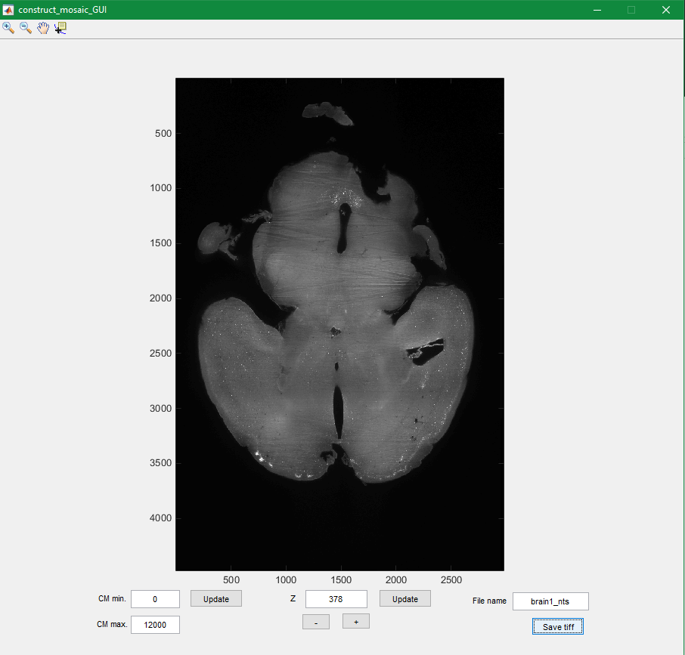

Run select_params
Double-click the select_params.exe file. Click “Save test set”.
(Saved nifti file appears in: study_folder\iDISCO_QUANT\mosaic)
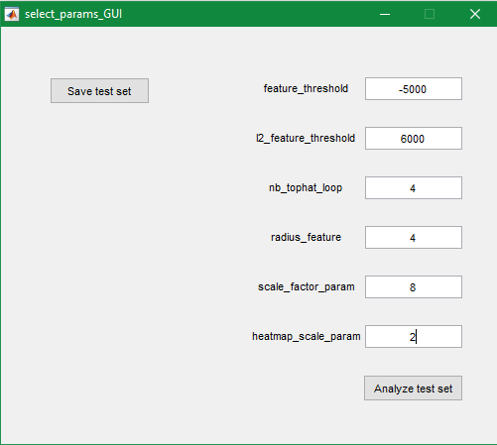

Click “Analyze test set”
”Im_feature.nii.gz” contains a feature image based on blob filtering. The ”feature_threshold” param is used to discard all pixels with values > the threshold in “im_feature.nii.gz” .
A gradient images is computed from ”im_feature.nii.gz” and saved as ”im_feature_grad_final.nii.gz”.
The parameter ”I2_feature_threshold” will discard all cells with a value less than the threshold in ”im_feature_grad_final.nii.gz”
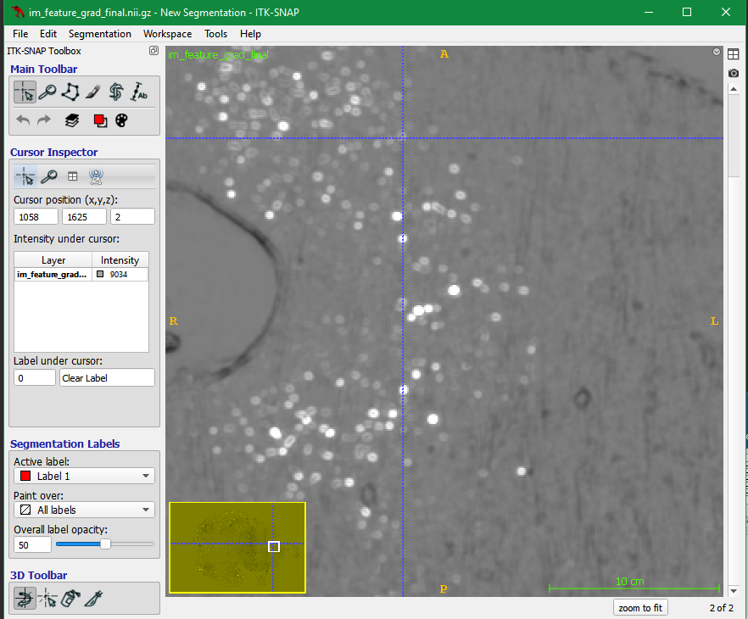 | 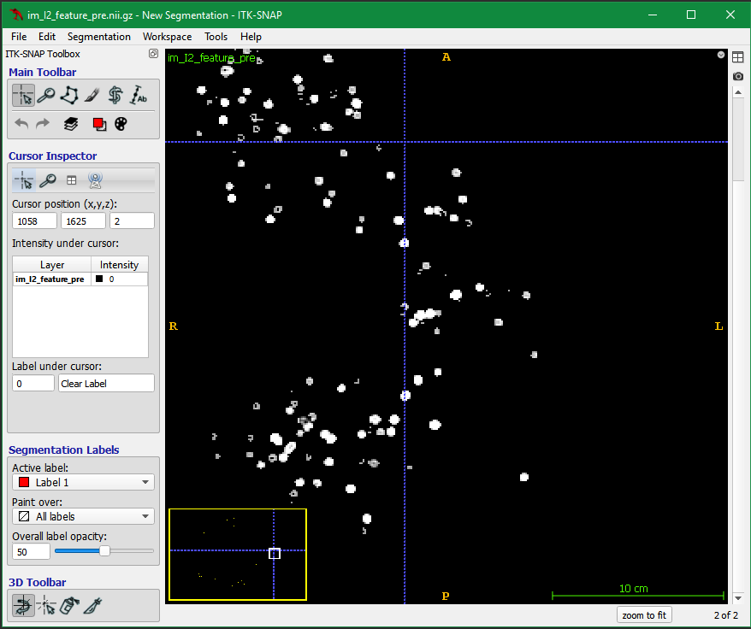

Next, a top-hat filter is applied to ”im_feature_grad_final” resulting in: ”Im_I2_feature_pre.nii.gz”.
The algorithm now tries to separate clustered cells into individual cells based on the ”nb_tophat_loops” parameter and saves the images as ”I2_feature.nii.gz”. A lower value will cause less separation and a higher value will cause more separation.
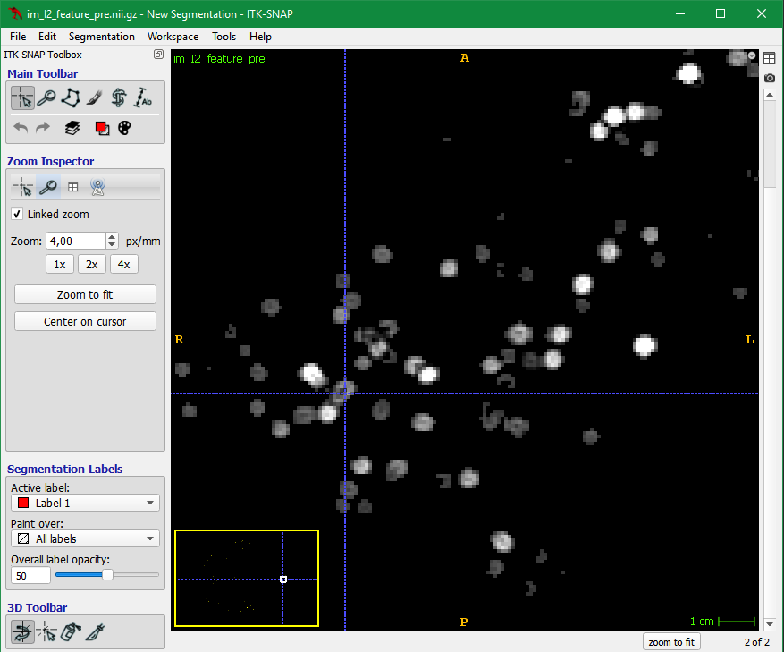 | 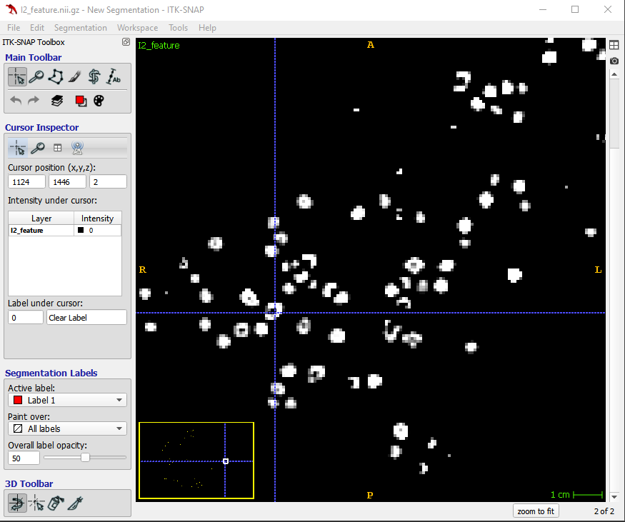

Last step is to convert the ”I2_feature.nii.gz” into a heat map by summing uniform intensity disks placed at the position of each detected cell. The disks will have a intensity value equal to the ”heatmap_scale_param” and a radius based on the “radius_feature” parameter. A larger “radius_feature” value will give a more coarse heat map.
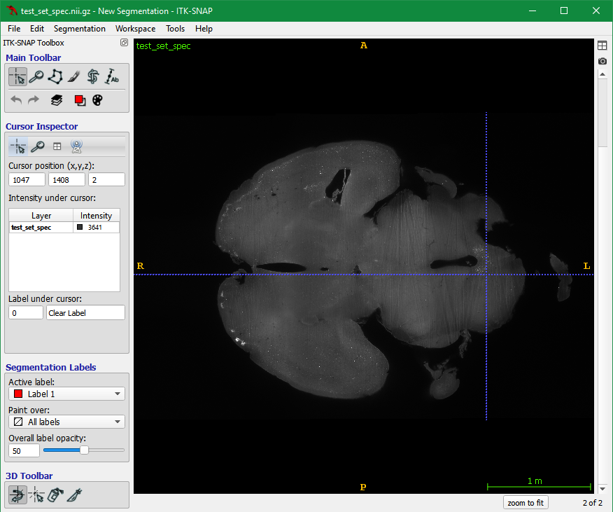 | 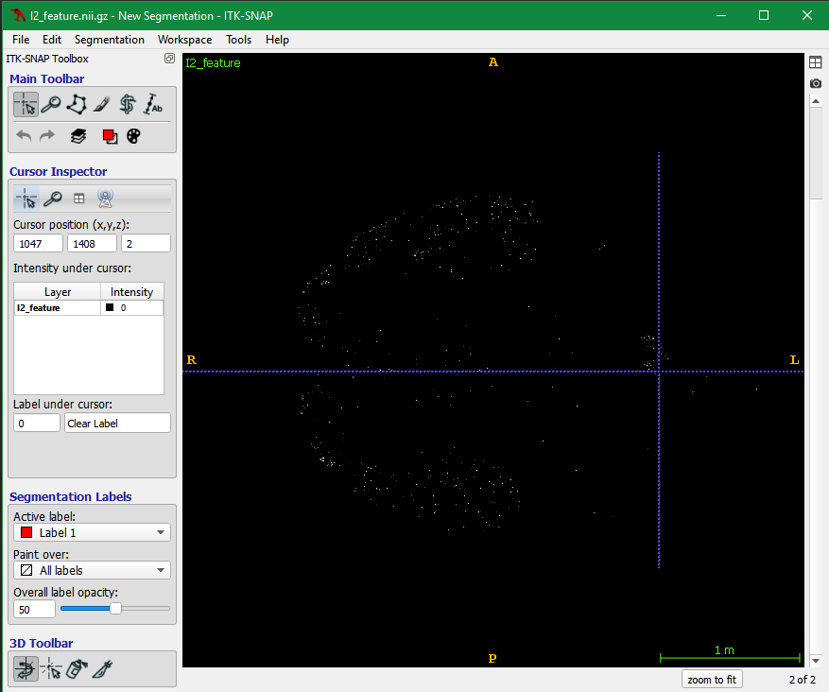 | 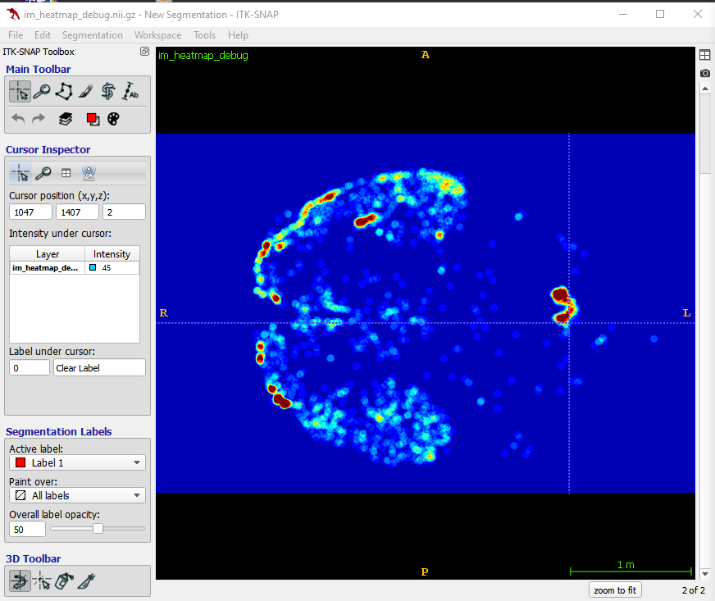

When all parameters have been optimized they must be transferred to the excel sheet named: “batch_info” under the “analysis_params” tab:
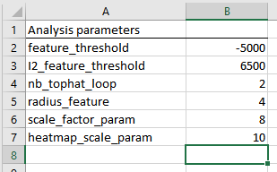

Runs iDISCO_quant
Fill in the rest of the batch_info excel file.
In “analysis_info” the “threshold for volume measure” should be set as zero. The threshold will discard all voxels in the heat maps below the threshold value. If you have noise in the heat maps it may be useful to increase the threshold value.
Resolution info and channel info should not be changed.
The list of brain regions in the ”analysis_info” tab are the ones for which statistics will be computed. A full list of brain regions that can be included can be seen in: “C:\myXT\brain_atlas\snap_labels_large.txt”
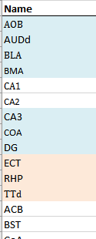

Next, add the path to the tiff files for each brain in each study group under it’s own tab in the excel sheet.
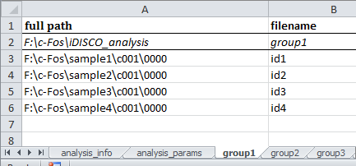

The first row contains the path to the average brains which will be computed. It must point to the “iDISCO_analysis” folder within the study folder.

When info for all groups are filled in, run: “iDISCO_quant.exe”. NOTE it must be run as administrator:
Right click->Run as administrator

In the pop-up window click “select folder”. Select one or more study groups to analyse. Click “OK”
A number of progress bars will show the progress of the algorithm. First, heat maps are created and afterwards aligned to the brain atlas.
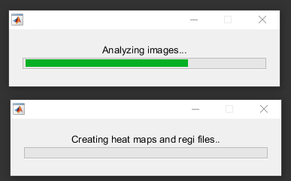

Check atlas alignment
As the scan settings of the light sheet data may differ between experiments it is important to check the alignment quality between the study samples and the brain atlas. When” iDISCO_quant.exe“ has finished the following files should be located in the sample folder:

First inspect “im_auto.nii.gz” and “im_auto_iso.nii.gz” by opening the files with ITK-SNAP. The files should look similar to the provided example images below. Please notice the orientation of the brain as well as the shape of the brain. The file “im_auto.nii.gz” is the down sampled raw data of the auto-fluorescence channel. The shape of the brain may seem stretched due to non-isotropic resolution during image acquisition. The file “im_auto_iso.nii.gz” should display the auto-fluorescence channel with a non-stretched appearance.
im_auto.nii.gz | im_auto_iso.nii.gz

If” im_auto_iso.nii.gz” does not look satisfactory please modify the “compress parameter” (marked by red circle in image below) in: “C:\myXT\brain_atlas\iDISCO\affine_iso_params_tile.txt”. A larger value will compress the brain more, while a lower parameter will compress the brain less. Save the modified file and re-run”iDISCO_quant.exe” (remember to run as administrator). The file “regi_vol.nii.gz” is a pre-processed version of “im_auto_iso.nii.gz” which is used in atlas alignment computations.
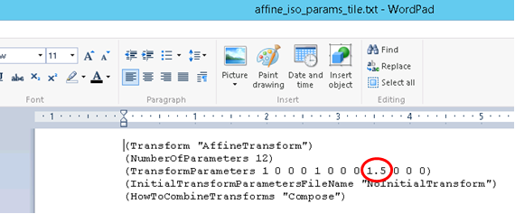

Next, inspect the sample alignment to the atlas. The alignment is performed between “regi_vol.nii.gz“ and an intermediate atlas template named “C:\myXT\brain_atlas\allen\lsfm_template_auto_nresult_man.nii.gz”. Open the atlas template file with ITK-SNAP and compare to “regi_vol.nii.gz”.
lsfm_template_auto_nresult_man.nii.gz | regi_vol.nii.gz

You will notice that the brains are not aligned. To check the result of the alignment open “auto_bspline_final.nii.gz” and compare to the atlas template:

lsfm_template_auto_nresult_man.nii.gz | auto_bspline_final.nii.gz

The brains should now be aligned.
Trouble shoot tip:
If the file “auto_bspline_final.nii.gz” is not located in the sample folder and you instead see a file named: “atlas_aff.nii.gz” it could mean that something went wrong during the alignment computations. If this happens please check the above steps and make sure that “regi_vol.nii.gz” looks reasonable. Then delete all files in the sample folder except for the tiff files and re-run “iDISCO_quant.exe” (remember to run as administrator). The problem may also be due to folder permissions so please try to update the folder properties and make sure “Read-only (Only applies to files in folder) is un-checked.

Compute group average heat map
Run “avg_brain.exe” from the study folder.
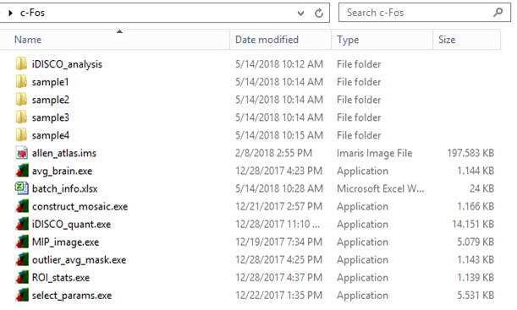

Click “Select folder”
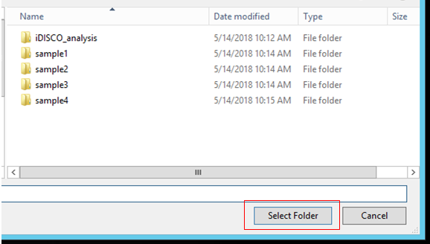

Select the group for which the average brain activation heat map signal should be computed and click “ok”
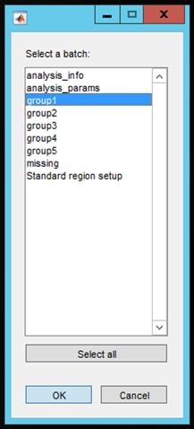
The average brain will now be computed. After the computation two nifti files will appear in the “iDISCO_analysis” folder inside the main study folder. The first nifti file contain the average activation signal, e.g. “group1.nii.gz” while the other nifti file contains a mask which may be used to manually remove noise or outliers from the average signal.
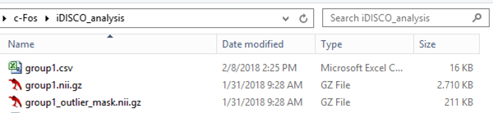

Comparing brain activation signals
It is also possible to compare different brain activation signals in the same Imaris file. After the average brain has been computed a nifti file is saved with the result, e.g “group1.nii.gz” as seen above.
This nifti file from each group can be imported into the “allen_atlas.ims” placed in the main study folder and be directly visually compared. First, open the “allen_atlas.ims” file.
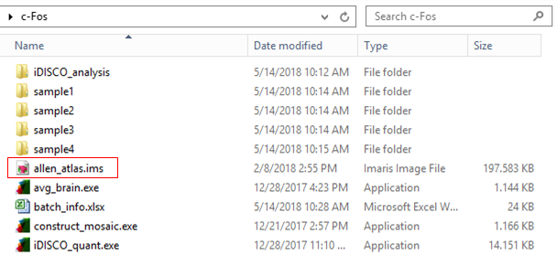

Goto: “Image processing” -> “CSBJ Open nifi”

Select “Add channel to existing file” and click “ok”

Navigate to the “group1.nii.gz” file. Select it and click “Open”

The average distribution signal will now be imported as a separate channel in the imaris file.
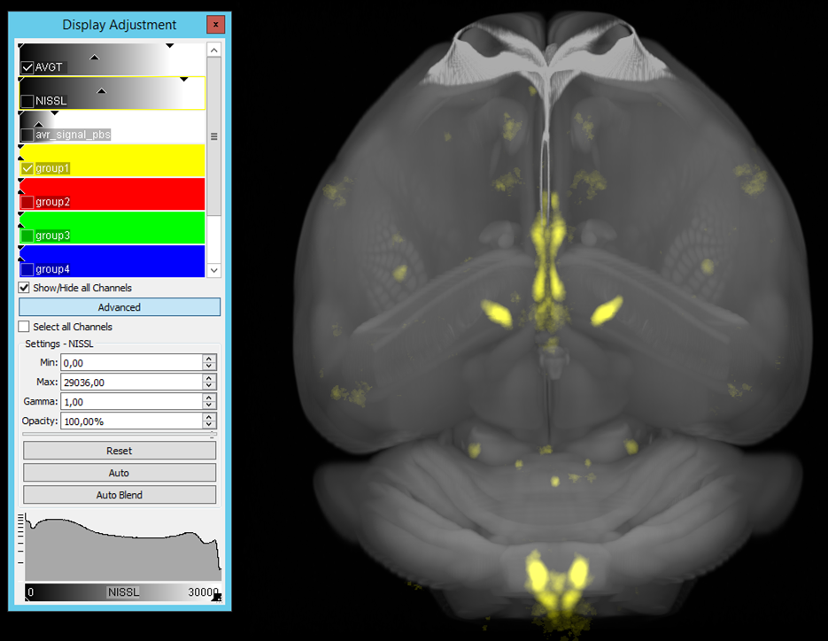

Repeat for all study groups.

Subtract vehicle signal
To focus on the treatment specific c-Fos signal in the groups it may be beneficial to subtract the c-Fos signal from vehicle (negative control) animals. Here we assume that channel 4 contains a treatment average activation signal, and that channel 5 contains a vehicle average activation signal. To subtract the vehicle signal from the treatment signal do the following:
Goto: “Image processing” -> “Channel Arithmetics”

Type in the desired subtraction. Note that e.g. “channel 4” is referenced as “ch4”. The vehicle subtracted treatment signal will be returned to Imaris as a new channel.

Extract statistics
Run “ROI_stats.exe” from the study folder.

Click “Select folder”

Select the group for which the ROI stats should be computed and click “ok”

The ROI stats will then be computed. The results will be saved as a .csv file in the study folder. For statistic comparisons use the value in “brain_region_name Tot_sig”. This value contains the voxel-wise summation of heat map intensity values for each brain region selected to be included in the analysis.

